Through-The-Earth (TTE) underground communication, sensing and location-finding - Algorithms
Researchers
Technion, EE Dept.: Prof. Moshe Nazarathy
Rafael: Dr. Eran Greenberg & Mr. Evyatar Hemo
Relevant topic Engineering
Abstract
The proposed research addresses two main issues in underground warfare, as well as in related civilian applications, such as mining communication and safety, disaster rescue operations, etc.:
(i) Through-The-Earth (TTE) communications (from/to surface to/from tunnel).
(ii) Remote-Metals-Sensing (RMS) via the underground medium.
Equipment
A request for equipment grant submitted in parallel to the Pazy Foundation

Through-The-Earth (TTE) underground communication, sensing and location-finding - Algorithms
Executive Summary
In recent years, there has developed an ever growing threat posed by underground tunnels around the globe. The proposed research addresses two main issues in underground warfare, as well as in related civilian applications, such as mining communication and safety, disaster rescue operations, etc.:
(i) Through-The-Earth (TTE) communications (from/to surface to/from the tunnel).
(ii) Remote-Metals-Sensing (RMS) via the underground medium.
We propose, for the first time to our knowledge, to harness the full power of novel Digital Signal Processing (DSP) algorithms, in order to substantially improve the performance of TTE and RMS systems (i) and (ii) above. The proposed DSP techniques, modern communication and adaptive control principles comprise: Multiple-Input-Multiple-Output (MIMO) adaptive equalization and echo-cancellation, Orthogonal-Frequency-Division-Multiplexing (OFDM) processing, error correction coding and extremum-seeking real-time optimization.
In particular, we propose to investigate MIMO-OFDM frequency-domain magneto-quasi-static transmission over the underground medium, optimizing it according to water-filling principles, accounting for large spectral variations of attenuation over the broadband VLF (say 1-10kHz) band, and adapting to frequency-dependent environmental VLF interference.
A key feature of our essential approach for both TTE-communication and Remote-Metals-Sensing is that it not just DSP-based; It rather follows an intertwined innovative combination of digital processing and magneto-quasi-static-analog processing, yielding joint cross-layer designs in the Very-Low-Frequency (VLF) range, having the analog and DSP layers work in unison, combining digital + analog processing to yield substantially improved performance.
On the transmit side, we shall investigate a novel technique for generating intense AC magnetic fields at unprecedented high levels, yet without requiring prohibitive voltages, by means of our hereby proposed patent-pending sub-banded transmission method, based on a tight array of multiple mutually-decoupled sub-coils, each fed by a digital sub-band.
This is complemented on the receive side by ultra-sensitive VLF magnetic detection techniques based on very low-noise-figure magnetic sensors (close to the thermodynamic limit) equipping our AC magnetometers with robust mitigation of near-far-interference (cross-talk from the transmitter into the receiver) by means of extremum-seeking adaptive real-time optimization algorithms. We shall further research, for the first time, a novel adaptive technique for cancellation of environmental VLF interference (investigating both data-aided and blind adaptive MIMO processing approaches).
Finally, using tri-axis AC magnetometers, we aim to endow reception with spatial-awareness, determining mutual locations of transmitter and receiver or of backscatter-sensed metals by means of 3-D MIMO processing and also actively steering (“beamforming”) the magnetic fields for optimal performance and improved discrimination of remotely-sensed-metals.
Scientific background
In this section we review relevant state-of-the-art items related to our underground communication and remote-sensing research objectives, based on magneto-inductive techniques, and the associated applicative motivations. The reviewed techniques are: Through-The-Earth/Wall transmission, remote-metals-sensing, proximity metals detection, near-field magneto-inductive localization.
Tunnels warfare and underground civilian applications (mining, rescue operations, etc.)
In recent years, there has developed an ever growing threat posed by underground tunnels around the globe. From terror tunnels in the Israel-Gaza border to smuggling tunnels along the U.S-Mexico border, adversarial subterranean activity has caused loss of human life and substantial socio-economic damages [1].
Multiple challenges emerge in underground warfare and various approaches have been considered. Among those, two related challenges in scope of the proposed research are:
- Tunnels Communication – from/to the tunnel to/from ground surface and via tunnels
- Tunnels Detection – determine tunnel presence and its route [2].
Under the heading tunnels communication (a), one sub-objective is to establish reliable two-way communication between on-surface command posts and troops/robots exploring the tunnels. This form of communication is typically referred to as Through-The-Earth (TTE) transmission [3]–[7][8]. TTE methodology also has civilian applications, e.g. transmission from/to the surface to/from personnel down into mines, sewers, etc.. Due to the unique propagation properties of electro-magnetic waves in the underground medium, standard communication schemes just do not work, leaving the TTE challenge currently unaddressed.
A related technology is Through-The-Wall (TTW) transmission, whereby the challenge is to penetrate fortified construction structures (bunkers, basements, high-rise buildings, stacks of multiple concrete walls) wherein otherwise conventional RF communication would be prohibitively attenuated. Related civilian applications are tracking and communicating with fire-fighters and rescue workers in disaster situations.
TTE/TTW State-of-the-art: To overcome the excessive propagation attenuation of electro-magnetic waves in the underground medium, which rapidly rises with frequency, Very Low Frequency (VLF) else known as Long-Wave communication (in the KHz range) has been considered, e.g. [4], [6], [9] (Fig. 1). Several north-American companies attempted such portable solutions [3], geared towards both civilian mining and security applications, with typically inconsistent / poor performance results for the TTE task, indicating that even transmitting audio (voice) through the underground outstands as a major challenge – e.g., one enterprise, which boasts voice transmission in its datasheets, just managed to transmit a few tens of bits of text data but no reliable voice passed through.
Under the heading tunnels detection there are multiple alternative methods – the detection challenge turns out to also be exceedingly difficult to robustly attain. Our proposal will address one tunnels detection approach which surprisingly turns out to be closely related and partially overlapping with the tunnels communication techniques:
c. Remote metal sensing – an extension of proximity metal detection
Remote metal sensing is an approach to detect a tunnel by determining the presence of conducting objects within the tunnel, while assessing characteristic electro-magnetic signatures of such metallic objects, hopefully discriminating against the weakly conducting ground medium which may also be non-uniform, contain cracks, gaps, stray metallic objects, etc.. Such remote metal detection system may be implemented as a vehicle-towed system for scanning over the ground. In a sense, the remote-metal-sensing approach to tunnel detection would be a novel extension of conventional proximity metal detection techniques such as land mine detection and unexploded ordnance (UXO) detection [10]–[16], and treasure hunting [17] (yes, there is an active metal detectors market for hobbyists’ looking for gold) which functions are performed by scanning over the ground with proximity metal detectors which typically have sub-meter range or even less. Proximity metal detectors are evidently also ubiquitous in security scanning at portals or gates in public places such as airports, malls, stadiums, both handheld ones as well as detectors attached to the portals.
Proximity metal detection state-of-the-art: Such sub-meter-range metal detectors [10]–[16] resort to Low-Frequency (LF) magnetic induction based on pulsed or CW AC magnetic fields (more advanced ones may use multiple-CW signals), inducing eddy currents in the target metals, which perturbations are sensed by pick-up coils, often differentially. More sophisticated metal detectors are able to discriminate between different types of metals based on the characteristic impulse response of the induced voltages.
Remote metal sensing state-of-the-art: Here the principle of operation is similar to that of proximity metal detection, however the requirements would be orders-of-magnitude more stringent. The VLF signal from the transmitter fills up the near field comprising the metals to be detected, such that the varying magnetic fields induce eddy-currents in the metals, which currents act as secondary transmitters which propagate back to the Rx. The transmitter (Tx) and the co-located or proximity-located receiver (Rx) together form a transceiver (TXR).
The remote-metal-sensing state-of-the-art is classified – we are not aware of any public literature – but it is very likely that the problem of substantially extending metal detector operating range from sub-meter up to tens of meters, striving for remote detectability via partially conductive ground media hindering field penetration – is still standing unsolved.
Moreover, it is unknown if classified remote-metal-sensing systems might have attained capabilities to discriminate types and shapes of the remote metal objects. Such capability is partially available with proximity detectors for land mines and unexploded ordnance (UXO), but its extension from proximity detectors to remote detectors would be challenging.
To the best of our knowledge, state-of-the-art remote-metal-sensing systems are currently location-blind, namely they may just sound alarms indicating presence of metals at some radius, say a few meters or in the best case tens of meters, but they would have no sense about the directions at which the sensed metal objects are actually located around the sensor. We conjecture that usage of orthogonally-oriented direction-finding sensing coils might endow the remote-metal-sensors with coarse localization capability, which would be useful to reduce false alarms, this has not been pursued yet, to our knowledge.
Proximity near-field magnetic sensors with localization capability: Given a pair of 3-axis concentric coils (henceforth referred to as 3D-coils) typically mutually spaced at distances of the order of a meter, with one 3D-coil used as Tx and the other 3D-coil used as Rx, an algorithm was worked out in the classical textbook by Kuipers [18], determining both the direction cosines of the line linking the centers of the two 3D-coil arrays as well as the orientation of the Rx coils orthogonal X’,Y’Z’ axes relative to the body X,Y,Z reference frame of the Tx system. The algorithm is based on exciting each of the three X,Y,Z coils of the Tx array in turn with calibration signals, and measuring the three voltages induced in the three Rx X’,Y’,Z’ coils. Several companies (Polhemus, Elbit, Sixense (now Razer Hydra)) applied this technology for military (helmet pointing systems) and civilian (medical, gaming) purposes.
Research objectives and relevance / importance
The proposed field of research addresses the conception and investigation of novel digital signal processing (DSP) algorithms for a variety of magneto-inductive communication and remote-sensing applications operating at VLF and LF frequencies. We aim to endow the magneto-inductive (MI) communication + remote sensing twin apps with spatial-awareness novel capability. We aim for more efficient/sensitive MI transceivers by advances in DSP algorithms, cross-layer integrated with novel improved MI analog front-ends.
We generally target in parallel the two related applications of communication (a), vs remote sensing (b), as listed immediately below. These two applications turn out to have substantial mutual overlap (as well as some distinctions). We also aim to further endow both types of systems, (a),(b), with spatial-awareness, (c), i.e., with location-finding capability.
Concrete scientific objectives in terms of systems conception, investigation, determination and extension of performance limits, optimized design and experimental demonstration are listed below. We remark that all these itemized objectives are research-worthy, either currently unavailable or just partially available but currently inferior in performance:
- TTE/TTW Communication system: ultra-efficient, long-reach, high-rate, capable of carrying data, compressed voice and possibly even a compressed video channel.
- TTE/TTW Remote Metals Sensing system: ultra-sensitive, discriminating metal type and object footprint, robustly maximizing remote detectability of specific metals while minimizing false alarms.
- Spatial awareness: location-finding and tracking for the underground communication. In the TTE app (a), the ground surface station would track the remote TXR location; In the remote-metals-sensing application (b), we aim for approximate angular sector localization of the confined underground volume containing the sensed metals closest to the sensor (without being able to resolve individual objects). Such angular awareness would improve discrimination against false alarms from metal bodies on the surface and provide useful spatial information re the actual location of tunnels to be detected.
- Impairments mitigation, counteracting three major types of disturbances/distortions:
(i) Cancellation of the near-far-interference (NFI) cross-talk from the strongly emitting Tx into the nearby ultra-sensitive Rx. Note that NFI is a major limiting factor, plaguing both TTE communication and remote sensing systems. The proposed NFI cancellation is to be researched for full-duplex transmission over different uplink and downlink bands, as well as for more demanding Simultaneous Transmit and Receive over same spectrum.
(ii) Substantial reduction of interfering environmental VLF electro-magnetic background signals picked-up in the magnetic antennas, which interferences are uncorrelated with the TTE/TTW intentional transmissions (applicable for both contexts (a) and (b)).
(iii) DSP adaptive equalization of the medium (transmission channel) to mitigate of the effects of the partially conducting media (soil/walls) on transmission/sensing.
Results and achievements expected from the research
To recap the big picture we expect to derive new methods for DSP-controlled magneto-inductive transceiver analog front-ends shared by both applications (a),(b) as well the requisite set of communication and DSP algorithms to be validated, simulated and experimentally demonstrated. Endowing both applications (a),(b) with spatial awareness (c), would provide key operational advantages for the user, but it turns out that it would also improve transmission / sensing performance, by allowing “field steering” (the equivalent of beamforming) controlling the orientation of the transmitted fields to improve sensitivity of the transmission link (a) as well as enable improved characterization of the sensed metals in (b). Mitigating the three types of impairments (NFI, environmental noise and ground conductivity) listed in (d) would make our MI transmission and remote-sensing systems particularly sensitive, yet robust, improving overall system performance
In the context of the TTE/TTW communication application (a): we aim for higher-rate, longer-range, reliable two-way transmission up to tens or potentially hundreds of meters TTE/TTW range of at least data and voice under a variety of soil/walls types and conditions including “worst-case” scenarios. It would be a formidable research outcome to be able to TTE/TTW transmit (compressed) video, enabling for the first time visual relay of robot vision. In addition, the transmission would be combined, for the first time, with spatial-awareness: localization and tracking from the ground of the current location of the portable TXR within the tunnel in TTE transmission or within fortified buildings or rubble in a disaster site in the TTW related application.
In the related context of the remote-metals-sensing application (b): we aim to increase the system sensitivity, discriminating metals type, footprint, robustly maximizing detection and minimizing false alarms by attaining at least approximate localization of the angular sector subtended by the metals within the sensed/detected underground tunnel, as well as calibrating away the presence of metals in the vehicle platform carrying the TXR.
Detailed description of the proposed research
The listed objectives have not yet been referred to how they are to be concretely achieved – preliminary concepts and their scientific principles and specific technological approaches underlying these targeted objectives plus some initial results are now detailed.
Research methodology and tools
Commonalities vs. distinctions of the techniques of TTE/TTW and remote-metal-sensing:
Let us explain how researching and solving the TTE/TTW communication challenges would also position one to much better address the remote-metals-sensing challenge. First, we remark that TTE/TTW transmission require one-way communication from the Tx to the Rx over some distance (say tens or hundreds of meters) whereas in remote-metal-detection, the Tx and Rx are co- or closely- located but there is round-trip propagation to the remote metals which backscatter the AC magnetic field (the causal chain is via Faraday’s, Ohm’s and Ampere’s laws: dB/dtEIB_{scatter}). While proximity metal detectors typically generate pulsed or CW magnetic induction (B-field) signals, we conjecture that more sophisticated frequency-domain OFDM signals, as proposed in our research for TTE transmission, will benefit long-range metal sensing as well, as most of the functions of the TTE TXR will be re-used (though the remote-metal-sensing TXR is to be further equipped with specific functionality, e.g. DSP to discriminate between different metals types and/or form-factors).
Cross-layer design: Our approach is to focus on the interplay and joint design of novel DSP algorithms realizing communication functions (implemented in FPGA or embedded SW platforms) over improved hardware structures for the analog-magnetic front-end. We claim that such tightly coupled cross-layer design (joint digital+analog processing) effectively fosters the interaction and mutual optimization between the analog-magnetic layer and the DSP layer. Thus, the proposed advances are based on designing the analog-magnetic front-ends to complement and take advantage the power of the DSP layer processing. This generic cross-layer approach will become apparent by way of example in our initial results below.
Novel techniques for generating ultra-intense fields in magneto-inductive ground TXR:
Both the TTE/TTW magnetic communication and remote-sensing systems would in principle immensely benefit from adopting massive Tx and Rx coils (with large area, lots of turns and intense currents in the Tx coil) for the ground surface TXR structure (wherein larger footprint/weight is tolerable, as opposed to the portable lightweight TXR to be deployed underground). Generating stronger magnetic fields would enable deeper ground penetration, improving link budget, increasing SNR/data-rate and/or transmission range. Similarly, having larger receive coils would enable to pick-up ultra-weak signals, again wielding a beneficial effect on link budget. Unfortunately, a straightforward “brute-force” attempt to use massive Tx/Rx coils and inject lots of power into the Tx coil would run into major difficulties: At the Tx side, driving large currents (~Amperes) in the VLF band (say up to tens of KHz) via massive coils (say with L of the order of Henrys up to tens of Henrys) would require generating voltages of the order 10⁴…10⁵ volts. For broadband operation (as required in the VLF band where in an exemplary design we aim to allocate the aggregate band of 1-9 KHz for the full-duplex transmission), there would be required complex impedance-matching circuitry (inefficient at large voltages) to mitigate spectral variations of the reactive elements (the large inductance and the shunt capacitances). In the wake of excessive voltages, power-electronics design of the Tx would become prohibitive.
Dually, on the Rx side, attempting to use very large coils in order to boost sensitivity would be accompanied by enhanced distributed capacitive parasitics, which would interact with the inductances to severely limit detection bandwidth, calling for extremely complex all-analog spectral equalization techniques which would be associated with much enhanced noise figures precluding the sought sensitivity improvement.
State-of-the-art of MI Tx and Rx vs. our objectives: Constrained by the limitations on the Tx/Rx coil sizes and on the driven currents (at the Tx side) commercially available technology provides performance (for 1-10kHz bandwidth) of the order of 10 fT/sqrt[Hz] Rx sensitivity (noise-equivalent field) and 10 ampere-m² magnetic moment at the Tx. We aim to improve the Rx sensitivity by a factor of ~10 and raise the Tx magnetic moment by a factor of ~100.
In “Initial results” below we explain our patent-pending concepts to enable the adoption of such massive Tx/Rx coils (with large currents at the Tx side) based on DSP+PHY design.
OFDM for communication TXR to improve TTE/TTW transmission:
We propose, for the first time to our knowledge, to adopt coded OFDM modulation format for TTE transmission in order to further boost the valuable system margin, optimally performing adaptive equalization of the received signal in the presence of sources of spectrally-variant and time-variant noise and interference sources (e.g., VLF-band whistlers and hums as well as 50 Hz multiples and other spurious signals) encountered over the entire operating frequency band. Mimicking the handling of polarization fading impairment in optical communication, we propose a novel adaptive blind environmental noise-cancellation method, for actively reducing the atmospheric background noise in the VLF frequency band (which impinges upon the receiver along with the feeble useful signal).
Principal researcher’s expertise and track record and that of his EE Technion graduate student team to be leveraged in this context: world-class expertise in DSP communication transceiver design (in particular OFDM), with forte in adaptive algorithms, adaptive control and real-time optimization. Our team originally honed these capabilities in the context of ultra-high-speed optical communication, preparing us to be highly proficient in their scaling down and adaptation to the proposed magneto-inductive applications. The suite of digital signal processing (DSP) algorithms we previously developed for coherent optical communication [19] will be (hopefully) smartly adapted to TTE/TTW transmission research.
Initial results
Here we present initial results + initial concepts to be investigated in detail and enhanced in the course of the research (possibly conceiving additional new concepts), outlining our conceptual design concepts and current conceptual roadmap which will guide us at least in the initial stages of the research.
Preliminary underground transmission channel (model) model
The Rafael partner has generated a channel model for TTE underground propagation of VLF magnetic fields generated by a magnetic dipole Tx, including the eddy currents effects, parameterized by ground conductivity and also quantifying the level of VLF environmental interference and has collected experimental data on these relevant parameters.
For the channel moment evaluated by Rafael we have conceived a preliminary approach combining DSP and analog-magnetic layers innovative measures, as illustrated in Figs. 2-10, which are briefly surveyed: Fig. 2 shows our OFDM Rx adapted to the TTE channel, Fig.3 refers to the sensor flux-feedback based AC magnetometer and our optimized electronic front-end design, Fig. 4 describes our novel concept of sub-banded multi-sub-coil magnetic Tx design with ultra-large magnetic moment, Fig. 5 shows our generic DSP for Near-Far-Interference (NFI) cancellation by analog-domain and digital-domain echo-cancelling techniques. Fig. 6 details the realization of the generic NFI cancellation of Fig. 5, but in the context of the flux-feedback magnetic sensor of Fig. 3. Fig. 7 is our preferred approach to realizing the NFI cancellation of Fig. 6(b) specifically realized by incorporating the multi-sub-coil multi-sub-band design of Fig. 4. Next, Fig. 8 shows our faster direction-finding algorithm. Fig. 9 shows to alternative regime of TTE link operation, achieving capacity gain by transmitting independent data on the three spatial axes, vs. achieving power gain by beamforming (utilizing direction-of-arrival info of Fig. 8). Finally, Fig. 10 presents our concept of VLF interference cancellation by blind-source-separation DSP techniques. We emphasize that these are all preliminary concepts, still untested but this is precisely the objective of the research to investigate and validate the system-driven approach outlined here. We next elaborate on the DSP and analog-inductive layers and on their joint design.
Digital DSP concept and preliminary design
Proposed measures to enhance TTE transmission rate: A major problem in TTE/TTW communication is the low, inconsistently sustainable data rate – due to the excessive attenuation in the ground medium and non-uniform soil conditions. Our proposed concept is to provide extra system margin by improving SNR (enhance link budget) via multiple novel proposed measures pertaining to the digital and analog layers and their joint operation:
a. DFT-S OFDM advanced modulation format with adaptive spectral loading.
Adopt, for the first time in TTE/TTW transmission, to our knowledge, advanced modulation formats such as m-ary Quadrature Amplitude Modulation (QAM) over Orthogonal Frequency Division Multiplexing (OFDM) with DFT-Spreading (DFT-S) [19] and use adaptive loading per subcarrier, namely modify the sub-carriers powers and/or QAM modulation levels according to the Signal to Noise and Distortion Ratio (SNDR) at each subcarrier frequency, including possibly turning off sub-carriers at very low SNDR (SNDR will typically vary both because of environmental noise and RF disturbances and also because frequency response variations due to impedance matching). In terms of initial results, see [19] for a complete OFDM sub-band receiver block diagram, which we propose for magneto-inductive reception. While the MI application is different than the photonic one which we developed in [19], the generic OFDM design principles may be leveraged here. In particular, as per [19], we introduced an efficient filter-bank and used the DFT-S OFDM technique to reduce Peak-to-Average Power Ratio (PAPR) and DSP complexity. Related sub-banded DSP will be ported to current context.
b. 3D MIMO DSP for channel equalization and spatial-awareness .
In the context of localization (direction-finding) we shall adopt, for the Tx and the Rx magneto-analog front-ends, orthogonal 3D antenna arrays (three concentric coils in orthogonal planes, XYZ at Tx and X’Y’Z’ at Rx). In effect a 3x3 MIMO channel is set up (e.g., each of the received X’,Y’,Z’ B-fields are linear combinations of the transmitted X,Y and Z with direction/orientation-dependent coefficients). To enhance data rate (whenever the SNR supports it, e.g. at somewhat shorter Tx-Rx ranges) we propose 3D spatial multiplexing of data-modulated B-field components, signaling independent data over the X,Y,Z Tx magnetic antennas and extracting estimates of the X,Y,Z signals from the X’,Y’,Z’ linear combinations at the Rx by means of a MIMO adaptive matrix filter, operating either blindly or data-aided (setting up its coefficients based on the reception training sequences). In terms of initial results, in the optical transmission context we have already realized a similar MIMO system, albeit 2x2 dimensioned (with X,Y and X’,Y’ the respective transverse polarizations at the optical Tx and Rx), based on a novel Least-Radius-Directed algorithm, which is extensible to an arbitrary number of dimensions. Now, while MIMO multiplexing enhances data rate, in case the SNR conditions diminish (say the distance between the Tx and Rx is gradually increased as Tx walks away from Rx), we plan to gracefully switch to a MIMO beamforming mode of operation (Fig.9) reducing data-rate by a factor-of-3 while enhancing SNR by about a factor-of-3. In this mode, the same transmission signal is applied to all three X,Y,Z Tx axes, in appropriate ratios, in effect signaling over the largest eigenvalue of the channel matrix – in physical terms, in the magnetic current context, the Tx aims its magnetic moment to point to the Rx (by adjusting the three coils currents – the knowledge of the direction vector from Tx to Rx is provided by the direction-finding techniques described further below). To maximize SNR, the receiver then engages in so-called MIMO maximal ratio coherent combining, in effect performing spatial matched-filtering.
c. Error-Correction and Source Coding
We shall initially investigate the usage of error-correcting codes such, as the Polar codes, which we have already been using in the TeraSanta Magnet Program of the Israeli Chief Scientist (the unrelated application there is Tera-bit/s optical transmission), in order to enable relaxing the raw bit-error rate (BER) to ~10⁻² which improved by the error correction algorithm down to 10⁻¹⁵ at the expense of about 20% spectral overhead. However, since BER requirements for voice and data transmission are less stringent, we shall investigate relaxing the overhead of the error correcting code at the expense of BER.
As for source coding, this is not our direct expertise, but we shall cooperate with the DSP Laboratory of the Technion EE Dept., to adopt an efficient Video Compression algorithm in enable most efficiently further improving the capacity vs. video-quality tradeoff over the improved capacity link to be developed under the proposal.
d. Near-Far Interference (NFI) Cancellation and Simultaneous-Transmit-And-Receive (STAR)
Left unmitigated, the NFI impairment would severely limit the Rx, which attempts to listen to a feeble signal from faraway but is swamped by the near-by intense Tx. Our innovative adaptive magnetically coupled NFI cancellation initial concept is sketched in Figs. 5-7 based on the combination of an extremum-seeking (ES) DSP algorithm + a magneto-inductive measure. The preferred realization of Fig.7 is compatible with the structure of our flux-feedback magnetic Rx front-end design (Fig.3) and the multi-sub-coil Tx design of Fig. 4, as outlined below. NFI cancellation is performed in the magneto-analog-domain, based on an auxiliary third coil inserted within the front-end of our flux-feedback Rx (in addition to the Rx sensing and feedback coils of the trans-inductive sensor design) driven by DAC+DSP.
Our recent advances in real-time extremum-seeking optimization [20][21] provide the DSP layer to adaptively track the level of corrective subtraction of a variably attenuated copy of the Tx signal, superposed with negative sign over the Rx sensed field (by means of the auxiliary third coil) plus a recovery procedure in case the analog-front-end gets saturated. The expected result would be an accurate method of broadband NFI mitigation, applicable to full-duplex FDD transmission (different uplink/downlink bands), remarkably further enabling simultaneous transmit and receive (STAR), Fig. 5, doubling TTE transmission rate by enabling full-duplex over a common spectral band. The only pre-requisite for our robust NFI-cancelling system to be applicable is that the TXR system on the ground be initially designed such that Tx-to-Rx coupling be of the order of minus a few decibels, else the auxiliary coil field, which opposes the Tx field, would excessively reduce the net launched field.
Analog-magnetic physical layer+digital layer joint design: Our conceptual approach is based on several initial conceptual tools (recently submitted for patent-protection [22]):
- Flux-feedback Rx design: We shall base our receiver analog-magnetic front-end design on a Technion-conceived ultra-sensitive low-power AC magnetic sensor optimized design (Fig. 3(a)) implementing the generic concept of trans-induction (flux-feedback or magnetic-feedback) (Fig. 3(b)). The basic idea: in order to sense a field B_{s}, it suffices to generate a feedback field B_{f}=-B_{s} (nearly) cancelling the sensed field. The current needed to generate B_{f} (or a proportional voltage on a resistor) then provides an estimate of the field B_{s} to be sensed. Such a sensor was initially developed by Dr. Yoash Levron of Technion EE Dept., for unrelated 50 Hz electric current sensing applications [23]. With Dr. Levron’s assistance (see letter of coop) we have already improved (Fig. 3(a)) and shall further improve an ultra-sensitive magnetic sensor design to experimentally demonstrate this novel trans-inductive sensor structure up from 50 Hz up to higher frequencies in the VLF, LF, MF spectral ranges, as suitable for MI transmission (VLF for TTE, LF/MF for TTW). While AC magnetometers based on magnetic flux-feedback circuits have been previously disclosed [7], [24]–[26] (shown superior to other AC magnetometer types, such as [9],[27][28]), Dr. Levron has generated a much improved flux-feedback electronic design and we conducted extensive analysis in order to optimize SNR, yielding the sensor design of Fig.3(a). Our noise theoretical analysis and preliminary circuit simulations indicate that this design approaches the thermodynamic limit of nature (noise figure as low as ~3 dB, i.e. total noise is just double due to the thermal resistance of the coil alone, with a hypothetical ideal electronic circuit). Moreover, the novel magnetic sensor structure supports cancelling NFI by adding a third NFI-cancelling coil, as illustrated in Fig. 6(b).
- Intense field generation enabled by multi-sub-coil digitally sub-banded magnetic antenna
This novel MI Tx design concept proposed here was inspired by our DSP a-priori skills and achievements based on filter-bank signal processing (see the principal investigator’s review article [19] on the usage of filter-banks in optical communication – ported here to the analog-digital magneto-inductive cross-layer design): In order to realize a massive broadband magnetic Tx antenna, the key idea (Fig. 4) is to break it into multiple smaller antennas - partition the large coil into multiple sub-coils (say K of them), all in close physical proximity over a common “air-core” and drive each sub-coil with a distinct digital sub-band of the overall signal to be transmitted. The DSP processor organizes the transmitted spectrum into contiguous sub-bands. E.g., the DSP spectral partitioning is readily accomplished for the OFDM modulation format, as adopted here. The analog driver of each sub-coil is fed by a separate DAC signal, thus the DSP HW delivers a different spectral sub-band to each sub-coil, via an array of Digital to Analog Converters (DAC). But sub-banding alone is not sufficient - further required is electronic cancellation of mutual couplings between the multiple sub-coils, achieved by operating each sub-coil as a resonant circuit tuned to a different sub-band frequency; magnetically coupled frequencies from neighbouring sub-coils are then blocked by virtue of the staggered analog resonances.
- Deeply penetrating low-rate pulsed “mode-locking” – This is a novel third regime of operation which we propose for the magneto-inductive OFDM link (further to the other two 3D data-muxing and the 3D spatial multiplexing and MIMO beamforming regimes of operation proposed above). It is inspired by the unrelated concept of mode-locking in a laser cavity, whereby multiple modal frequencies on a grid get locked in phase to generate strong periodic pulses (with periodicity equal to the spacing between adjacent spectral lines). In the OFDM context, the “modes” are the OFDM sub-carrier frequencies or DFT-S groups (the sub-bands), e.g., if there are K=100 sub-bands over the 1-11KHz band (thus the main coil is sub-divided into 100 sub-coils), then a pulse-train with repetition rate of 100 Hz is generated, when the sub-bands are phase-locked with each pulse lasting 100 usec. Physically, the rotating phasors of the sub-coil fields get (collinear) aligned in phase and add up coherently every 10 msec, yielding an extremely intense field 100 stronger than that of each sub-coil (whereas in normal operation with uncorrelated sub-band data-signals, the sub-coil fields would just add up incoherently, on an RMS basis). This regime of operation may be used for initial link setup and/or for launching direction-finding training-sequences, or it may be engaged whenever the range increases such that the signal gets too weak under the other regimes – granted, the transmission rate now drops to, say, 100 baud, e.g. 400 Kb/s with 16-QAM or 200 Kb/s with QPSK, but at least some signal may get through at the extended distance, whereas none was received upon using other transmission regimes.
- Environmental VLF noise cancellation concept -As we aim for extremely sensitive magnetic sensors, the background magnetic disturbance, D(t), becomes a limiting factor – to partially mitigate it, we propose to engage in diversity reception of the desired underground signal, R(t), (along each of the X,Y,Z axes) superposed with the disturbance D(t), receiving two coherent linear combinations with different coefficients of these two signals, by means of a spatial layout (Fig. 10) with the Rx coils partially shielded in pairs by magnetic-isolation-sheets. The proposed structure replaces the three coils of a 3-axis AC magnetometer by 6 coils, paired up along the X,Y,Z axes, with magnetic absorbing material separating the two coils on each axis. Optimized magnetic design of such structure will be subject of research. The objective is to improve the condition-number of the 6x6 MIMO matrix describing the linear transformation from the vector [R_{x}(t), R_{y}(t), R_{z}(t), D_{x}(t), D_{y}(t), D_{z}(t)] to the vector of six voltages induced in the coils. A well-conditioned MIMO matrix may enable blind source separation techniques such as Independent Component Analysis (ICA) [29], suitable for this situation wherein we get we get six diverse mixtures of the desired signal and the VLF interference – analogous “cocktail party effect” problems have been tackled in MIMO acoustic signal processing [30] and in polarization multiplexing in optical transmission [31]. An alternative to be further explored is the applicability of ICA DSP for interference suppression with just three spatially orthogonal receive coils (in lieu of three pairs of coils separated by magnetic material), capitalizing on the fact that the directions of arrival of the interference vs. the useful underground signal almost never coincide.
- MI Localization techniques – the textbook by Kuiper [18] presents a complex algorithm for proximity near-field magnetic sensors with localization capability. Our preliminary results suggest simpler math methodology to address the problem, insight into which may assist us in the DSP layer for direction-finding: Using Dirac math notation with kets denoting column vectors and bras denoting their conjugate transposes, the 3x3 MIMO matrix (mapping the Tx magnetic moment vector |m> into the Rx induction field |B> is up to a constant given by M=3|r><r|-I, with I the 3x3 unity matrix and |r> the vector of direction cosines along the observation line linking Tx and Rx. The eigenvectors of M are |r> itself as well as any vector orthogonal to |r>. However, as the receive sensor is further rotated by a 3x3 rotation matrix R (relative to the Tx axes), the end-to-end MIMO channel matrix becomes C=RM. Performing a singular-value-decomposition (SVD) on the channel matrix, C, yields both |r> and R (details omitted, but we have not found references on approaching the problem with SVD, so this may be an alternative viewpoint on [18][32], though equivalent to it, thus of theoretical value (not clear yet if it is more or less computational efficient). But how to measure the end-to-end MIMO matrix C? The system ID suggested in [18][32] sequentially excites magneto-inductive link with unit vectors |x>,|y>,|z> in turn (i.e. time-multiplexing). Rather, we propose orthogonal-frequencies multiplexing, consistent with our OFDM format (Fig.8): The new concept: excite the X,Y,Z Tx coils with three different sub-carriers (their frequencies are selected on a regularly spaced spectral grid, hence the associated OFDM symbols are orthogonal. Thus, they may be decoupled by a Discrete-Fourier-Transform as used in the OFDM Rx. This would triple measurement speed relative to time-multiplex [18].
Responsibility areas of Technion and Rafael PIs + Infrastructure at the researchers’ disposal
Rafael: The research team at Rafael, has been conducting underground warfare R&D activities for the last five years. Experimental implementations have heretofore relied mainly on standard commercial-off-the-shelf (COTS) equipment. Rafael's lab is well equipped with state-of-the-art industrial-grade electromagnetic receivers, transmitters, amplifiers, filters, mixers, etc., as typically used for electromagnetic calibration, design and testing. The lab staff members have extensive experience in conducting underground field experiments and have acquired significant knowhow and insights regarding "real-life" constraints in the challenging underground transmission domain. In addition, a small-scale underground experiments facility is located on Rafael premises. This experimental underground test-bed is used for preliminary testing and prototyping prior to proceeding to large-scale complex underground experiments.
Technion: The EE principal investigator (PI) will be leading the overall system design in close cooperation with the Rafael team, as well as the Technion DSP algorithmic investigation and implementation. The PI is in charge of the Communication Lab in the EE Department of the Technion, generically equipped with conventional RF hardware, which will have to be augmented with specific equipment for the VLF and LF frequency bands. The lab staff members, comprising two tenured RF engineers + a researcher who retired from Rafael + a technician are highly trained in operating and maintaining RF equipment and handling electronic analog and digital circuits. The lab is also equipped with a dichroic chamber and with the state-of-the-art CST RF simulation software and. An additional relevant EE Technion lab, which will be closely cooperating in the analog power electronics aspects of the proposed research (see cooperation letter below), is the Power Electronics Systems Lab (PESL) of the new faculty member Dr. Yoash Levron, whose lab is in the course of being staffed up for power electronic work.
Work plan and milestones
Year1: Conceptual designs and simulations of the novel magnetic+analog front-end of the sensor (Rx) and Tx. *Design and manufacture of a first gen prototype of the ultra-sensitive flux-feedback based Rx front-end and its characterization with harmonic analog signals and with a conventional Rafael magneto-inductive Tx (milestone). *DSP OFDM Tx and Rx structural design and simulation and investigation of the basic transmission chain DSP algorithms (DFT-S OFDM, adaptive loading). *First realization of back-to-back digital->analog->analog->digital passband transmission (no magnetics) but with the ADC and DAC array (milestone). *Commencing the design and simulative investigation of the sub-banded multi-coil Tx-front-end. *Commence design and simulation of NFI cancellation technique including the modification of the Rx magneto-inductive front-end and the conception and simulative investigation of extremum seeking adaptive control algorithm for stabilizing the NFI. *Commence spatially-aware 3D-MIMO (location-finding+optimal beamforming) research: DSP algorithmic design and simulation.
Year2: Completion of the simulation of the sub-banded multi-coil Tx-front-end and its integration with sub-banded DSP; manufacturing of the multi-sub-banded Tx. *Integration and testing (with harmonic analog signals) of the multi-sub-banded Tx with the first gen magneto-inductive Rx. (milestone). *Integration of the novel magneto-inductive Tx, Rx front-ends and the DSP; testing, characterization, experimental demonstration (milestone). *Completion of the simulation investigating the NFI cancellation techniques, resulting in first-gen DSP algorithms; Design of second gen modified Tx and Rx to accommodate NFI cancellation.*Commence environmental VLF noise cancellation conceptual design and investigative simulation. *Complete 3D MIMO (location-finding+optimal beamforming) DSP investigation. *Commence HW/SW realization: New generation of Tx, Rx front-end, extended to 3-orthogonal axes magnetic antennas.
Year3: Completion of the environmental VLF noise cancellation investigation, design, manufacture and experimental realization (milestone). *Completion of the 3D MIMO system (Tx and Rx) for location-finding: investigation, design, manufacture, experimental realization and testing. *Investigation, optimization and testing of the three alternative regimes of operation: spatial-mux, MIMO beamforming and deeply penetrating low-rate pulsed “mode-locking” (milestone). *Demonstration of Simultaneous-Transmit-And-Receive bi-directional capability. *Commence work on metals-remote-sensing of metals – repurposing the TTE Tx and Rx into remote-sensor.
Year4: Field testing of the prototypes on real underground environments (milestone). *Error-correction Coding research. *Investigation and comparative characterization of performance of the additional regimes of operation. *Demonstrate the metal-remote-sensing TXR operation with actual remote metals (first above the ground then underground).*Research of methodologies to discriminate between the types and shapes of metals in the remote-metals-sensing system (milestone).

Figures
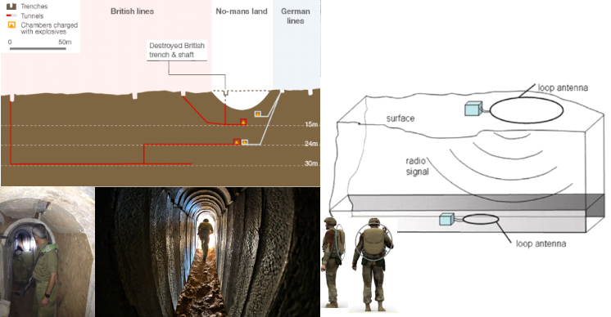
Fig. 1 Through-The-Earth (TTE) communication from the ground surface to/from tunnel, based on magneto-inductive transceivers with coil (loop) antennas operating in the VLF frequency band.
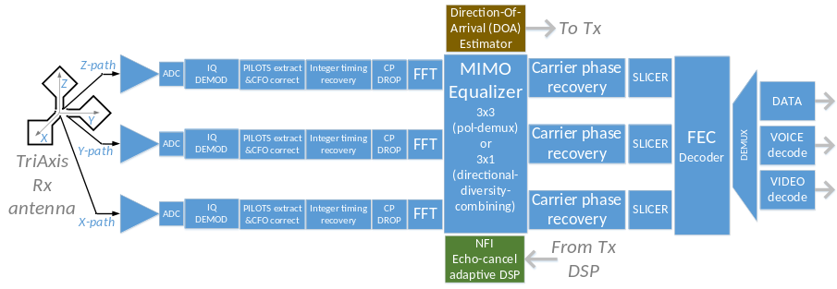
Fig.2 . OFDM receiver for magneto-inductive communication with tri-axis magnetic loop antenna in the VLF band.
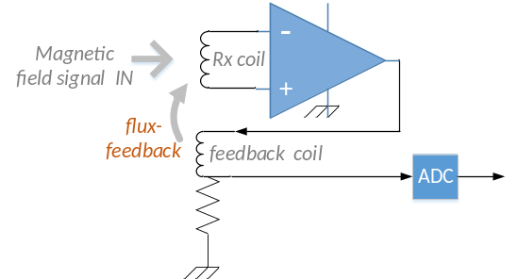
Fig.3 (left): Technion-conceived optimized design for ultra-sensitive low-power AC magnetic sensor (first gen.), worked out by Dr. Yoash Levron of EE – see attached letter of cooperation. This broadband (1KHz-100 KHz) design attains a record low noise figure of ~3 dB, implying that the total noise contribution of the whole circuitry is nearly equal to that of the thermal noise due to the ohmic resistance of the receive coil alone. (right): The salient flux-feedback or trans-inductive feedback features of the circuit of (left), according to known AC magnetometer principles (but the Levron design exceeds prior-art performance).
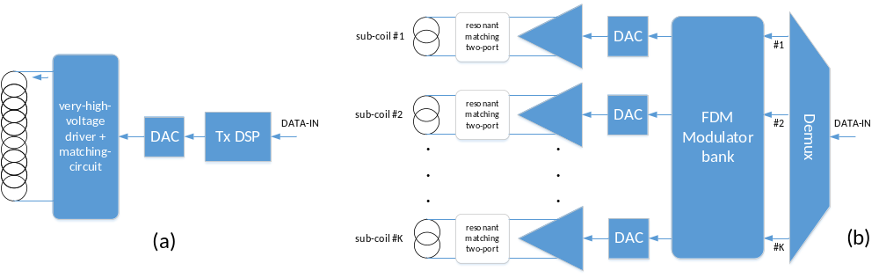 Fig.4. (a) Conventional Tx with massive coil for generation of intense AC magnetic moments would require an analog driver at ultra-high voltage plus complex, bulky and inefficient impedance-matching circuitry.
(b) Efficient large-magnetic moment broadband magnetic Tx antenna proposed design concept - supporting lots of turns, large area and intense driving currents through the turns while eliminating excessive voltages and complex and inefficient impedance-matching circuitry. The novel illustrated concept is based on partitioning the conventional large Tx coil into multiple sub-coils and driving each sub-coil by a distinct digital sub-band of the broadband signal to be transmitted, as generated by an FDM Tx system such as DFT-spread OFDM. Each sub-coil is narrowband-resonant at a different center frequency, hence the mutual couplings between sub-coils are suppressed (which is a critical enabler of the proposed method). Each of the K sub-coils has its inductance L_{sub} lowered by a factor K² relative to the reference conventional coil, hence the reactive voltage on each sub-coil drops by the same factor (for the same current, hence the same magnetic moment as in the reference case (a)).
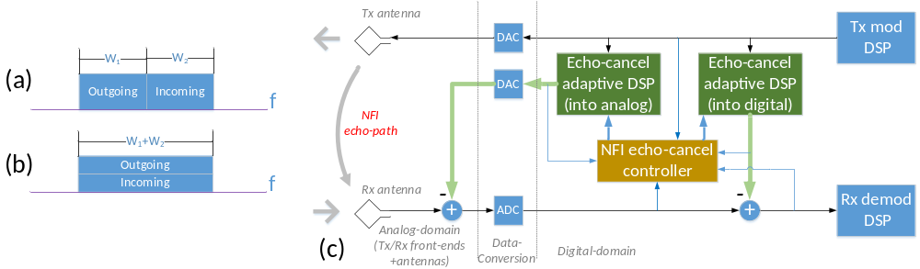 Fig.5. Full-duplex options and Near-Far-Interference (NFI) cancellation. (a) Full-duplex over disjoint spectral bands in the two directions. (b) Simultaneous-transmit-and-receive (STAR), achieving full-duplex over a common spectral band. (c) Block diagram of NFI cancellation. In both cases, (a),(b) substantial NFI cancellation is required, achieved as in (c) by a combination of two analog-front-end and digital domain “near-end-echo-cancellation” adaptive loops, each contributing tens of dB to the suppression of NFI. Unless NFI-echo-cancellation is practiced, the Rx analog front-end of the sensitive AC magnetometer is swamped by the strong NFI signal and saturates out.
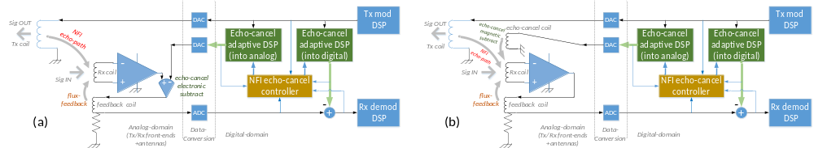 Fig.6. Generic flux-feedback (trans-inductive) analog design – indicating the most important features of the structure of the previous figure – but further innovatively equipped with analog Near-Far-Interference (NFI) cancellation analog and digital means realized by additively injecting with reversed polarity a properly filtered version of the Tx signal, according to two alternative options: (a) electronic additive injection (with minus sign) within the trans-inductive feedback loop, at the output of the amplifier. (b) Superposition (with minus sign) onto the field the sensing coil, by means of an auxiliary third magnetic antenna (coil). In both cases the analog subtracted signal is driven by an appropriately filtered and D/A converted version of the digital-domain Tx signal (see the next figure for a more abstract view of echo-cancelling system concept).
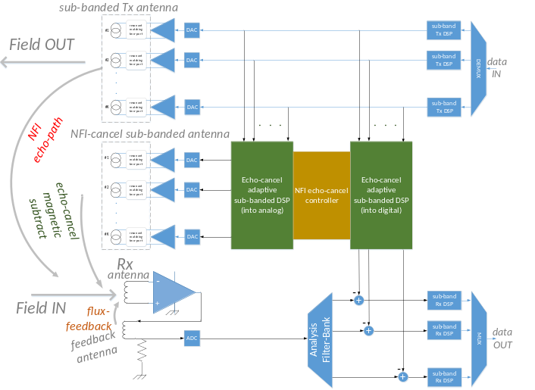
Fig.7. Proposed concept of magnetically coupled NFI cancellation, based on the combination of echo-cancellation DSP techniques + extremum-seeking (ES) DSP algorithm [21] modified to operate on the OFDM tones, in conjunction with a magneto-inductive coupling mechanism compatible with the structure of our flux-feedback magnetic Rx front-end design shown in Fig. 3. The concept presented here is further tailored to sub-band processing, as proposed for the Tx design in Fig. 4. Further elaboration of the abstract NFI-cancellation principles appears in Figs. 5 and 6.

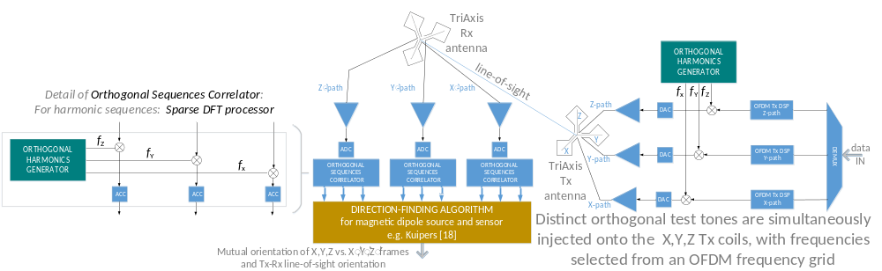Fig.8. Proposed concept for magneto-inductive direction-finding based on orthogonal-frequencies-multiplexing, tripling the acquisition rate by simultaneously applying orthogonal harmonic excitations (taken from an OFDM spectral grid) onto the three coils of the tri-axis MI transmitter and processing the B-field received X’,Y’,Z’ components (the novel frequency-domain concurrent system identification concept is inspired by our recent work in the field of extremum-seeking real-time optimization by means of OFDM-like techniques).
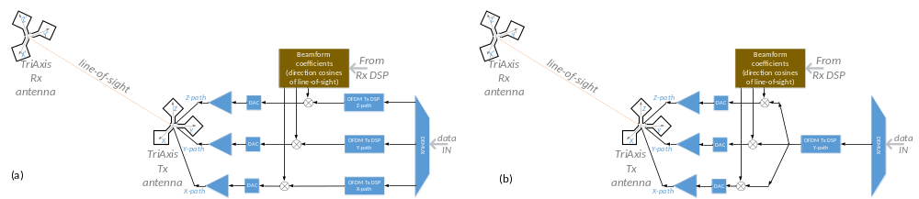Fig.9. Two proposed MIMO beamforming modes of operation. (a): independent data on all three axes. (b) beamforming mode: the same transmission signal is applied to all three X,Y,Z Tx axes, in appropriate ratios, in effect signaling over the largest eigenvalue of the channel matrix – in physical terms, in the magnetic current context, the Tx aims its magnetic moment to point to the Rx, by adjusting its X,Y,Z coils currents according to the direction cosines of the line-of-sight. The required line-of-sight direction is in turn estimated according to the direction-of-arrival algorithm of Fig. 8.
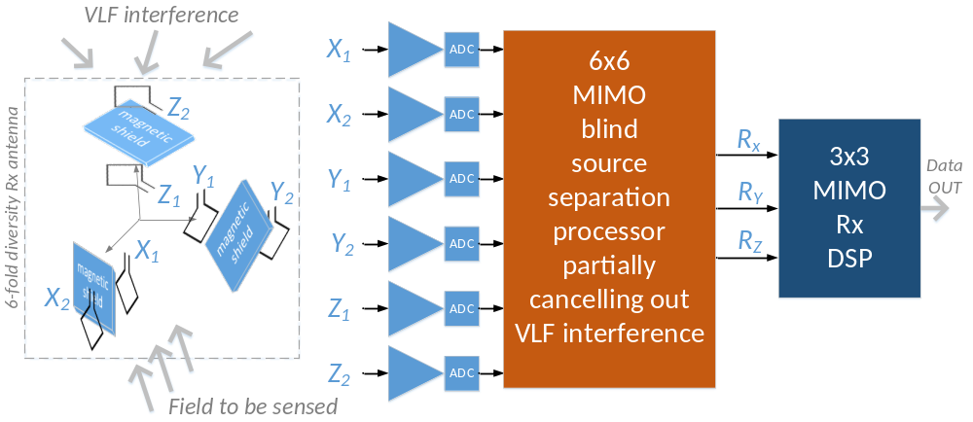Fig.10. Proposed environmental VLF interference cancellation concept based on a 6-coil AC magnetometer with the coils arranged in three pairs, each pair positioned along one of the X,Y,Z orthogonal axes and with sheets of properly shaped partial magnetic shielding material deployed within the structure in order to generate reception diversity among the multiple coils, such that the 6 received voltages would become diverse linear combinations of the desired underground vector components to be received plus those of the environmental VLF interference, also picked up within the Rx coils. The proposed MIMO DSP to follow the 6x6 MIMO magneto-inductive front-end is based on blind source separation methods such as Independent Component Analysis (ICA), recovering the original signals from their linear mixtures. The recovered VLF interference estimates are then subtracted off the mixture to yield accurate estimates of the X,Y,Z field components to be sensed.
References
[1] A. Herman, “Notes From the Underground,” Council on Foreign Relations, Inc., 2014. [Online]. Available: http://www.foreignaffairs.com/articles/141931/arthur-herman/notes-from-the-underground.
[2] C. Christou, J. C. Crager, L. Huffman, W. Kuklinski, E. Lebsack, D. Masters, and W. Shi, “An Innovative method to determine multi-system performance for the detection of clandestine tunnels,” 2012 IEEE Conf. Technol. Homel. Secur., pp. 43–50, Nov. 2012.
[3] M. R. Yenchek, G. T. Homce, N. W. Damiano, and J. R. Srednicki, “NIOSH-Sponsored Research in Through-the-Earth Communications for Mines : A Status Report,” Ind. Appl. IEEE Trans., vol. 48, no. 5, pp. 1700–1707, 2012.
[4] C. Lincan Yan; Waynert, J.; Sunderman, “Loop coupling and field distribution in earth for horizontal positioning in VLF/ELF through-the-earth wireless mine communications,” in Antennas and Propagation Society International Symposium (APSURSI), 2014 IEEE, 2014, p. 247,248.
[5] B. Yan, W. Zhu, L. Liu, K. Liu, and G. Fang, “Design of Induction Magnetometer Receiving Sensor for Through-the-Earth Communications,” IEEE Sens. J., vol. 15, no. 2, pp. 1139–1144, 2015.
[6] C. Lincan Yan; Waynert, J.A.; Sunderman, “Measurements and Modeling of Through-the-Earth Communications for Coal Mines,” Ind. Appl. IEEE Trans., vol. 49, no. 5, pp. 1979–1983, 2013.
[7] B. Yan, W. Zhu, L. Liu, K. Liu, and G. Fang, “An optimization method for induction magnetometer of 0.1 mHz to 1 kHz,” IEEE Trans. Magn., vol. 49, no. 10, pp. 5294–5300, 2013.
[8] L. K. Bandyopadhyay, S. K. Chaulya, and P. K. Mishra, Wireless communication in underground mines. Springer, 2010.
[9] M. B. Cohen, U. S. Inan, and E. W. Paschal, “Sensitive broadband ELF/VLF radio reception with the AWESOME instrument,” IEEE Trans. Geosci. Remote Sens., vol. 48, no. 1, pp. 3–17, 2010.
[10] S. J. Norton, I. Won, and E. R. Cespedes, “Spectral identification of buried unexploded ordnance from low-frequency electromagnetic data,” IEEE Trans. Geosci. n Remote Sens., vol. 2, no. 3, pp. 177–189, 2001.
[11] G. D. Sower and S. P. Cave, “Detection and identification of mines from natural magnetic and electromagnetic resonances,” in Proc. SPIE 2496, Detection Technologies for Mines and Minelike Targets, 1995, vol. 2496, pp. 1015–1024.
[12] J. Goutsias and A. B. Stract, “Towards a Unifying Optimal Approach to Mine Detection Problems,” in Proc. SPIE 2765, Detection and Remediation Technologies for Mines and Minelike Targets, 1996, vol. 2765, pp. 2–13.
[13] D. Guelle, A. Smith, A. Lewis, and T. Bloodworth, Metal detector handbook for humanitarian demining. Office for Official Publications of the European Communities, 2003.
[14] Y. Das, J. E. McFee, J. Toews, and G. C. Stuart, “Analysis of an electromagnetic induction detector for real-time location of buried objects,” IEEE Trans. Geosci. Remote Sens., vol. 28, no. 3, pp. 278–288, May 1990.
[15] C. V Nelson, C. B. Cooperman, W. Schneider, D. S. Wenstrand, D. G. Smith, and S. Member, “Wide Bandwidth Time-Domain Electromagnetic Sensor for Metal Target Classification,” IEEE Trans. Geosci. Remote Sens., vol. 39, no. 6, pp. 1129–1138, 2001.
[16] C. Baum, Ed., Detection and identification of visually obscured targets. Taylor&Francis, 1999.
[17] G. Edwards, Treasure hunting with metal detectors. Airleaf Publishing, 2006.
[18] J. Kuipers, B., Quaternions and rotation sequences: a primer with applications to orbits, areospace and virtual reality. Princeton University Press, 2002.
[19] M. Nazarathy and A. Tolmachev, “Sub-banded DSP architectures based on under-decimated filter-banks for coherent OFDM receivers,” IEEE Signal Process. Mag., vol. 31, no. Special Issue on Advanced DSP and Coding for Multi-Tb/s Optical Transport, pp. 70–81, 2014.
[20] J. Fisher, M. Nazarathy, A. Kodanev, N. Shitrit, M. Orenstein, A. Annoni, F. Morichetti, and A. Melloni, “Adaptive Controller of Two Tuning Phases in a Microring Based Binary Phase Shift Keying (BPSK) Modulator,” in Conference on Lasers and Electro-Optics (CLEO’'14), 2014, p. STh4M.
[21] J. Fisher, A. Kodanev, and M. Nazarathy, “Multi-degree-of-freedom Stabilization of Large-scale Photonic Integrated Circuits,” J. Light. Technol., vol. 8724, no. (accepted for publication in future issue - available on the web), 2015.
[22] M. Nazarathy and Y. Levron, “Near-field and far-field transmission and remote-sensing techniques - patent application,” 2015.
[23] Y. Levron, “Low Cost Current Sensor for line currents (50 Hz / 60 Hz) - patent application,” 2015.
[24] C. Cavoit, “Closed loop applied to magnetic measurements in the range of 0.1-50 MHz,” Rev. Sci. Instrum., vol. 77, no. 6, pp. 0–7, 2006.
[25] S. Tumanski, “Induction coil sensors - a review,” Meas. Sci. Technol., vol. 18, no. 3, p. R31, 2007.
[26] P. Andrieux, G. Clerc, and P. Tort, “Capteur magnétométrique triaxial pour la prospection magnétotellurique artificielle entre 4 Hz et 4 kHz,” Rev. Phys. Appliquée, vol. 9, no. 4, pp. 757–759, 1974.
[27] S. K. Harriman, E. W. Paschal, and U. S. Inan, “Magnetic sensor design for femtotesla low-frequency signals,” IEEE Trans. Geosci. Remote Sens., vol. 48, no. 1, pp. 396–402, 2010.
[28] E. W. Paschal, “Design of broad-band VLF receiver with air-core loop antennas Stanford Report,” 1988.
[29] a Hyvärinen, E. Oja, and a Hyva, “Independent component analysis: algorithms and applications.,” Neural networks, vol. 13, no. 4–5, pp. 411–30, 2000.
[30] I. Cohen, Y. Huang, J. Chen, and J. Benesty, Noise Reduction in Speech Processing, vol. 2. CRC Press, 2002.
[31] H. Zhang, Z. Tao, L. Liu, S. Oda, T. Hoshida, and J. C. Rasmussen, “Polarization demultiplexing based on independent component analysis in optical coherent receivers,” 2008 34th Eur. Conf. Opt. Commun., vol. 1, no. September, pp. 1–2, Sep. 2008.
[32] J. P. Rolland, Y. Baillot, and A. A. Goon, “A Survey of Tracking Technology for Virtual Environments,” Fundam. wearable Comput. Augment. Real., vol. 1, pp. 67–112, 2001.
[33] M. Nazarathy and J. Fisher, “Multi-degree-of-freedom Stabilization of Large-scale Photonic Integrated Circuits - Technion patent application,” 2014.

Budget
A. MANPOWER Principal, research assistants, associates and lab assistants.
Name (last, first) – TECHNION | Role in | % time | Salaries (in NIS)
 | project | devoted | 1st year | 2nd year | 3rd year | 4th year
Nazarathy, Moshe | PI | 30% | 0 | 0 | 0 | 0
Alex Tolmachev,  Research Associate, Hokker Aleph, PhD | research | 33% | 105,336 | 105,336 | 105,336 | 105,336
MSc student | research | 30% | 18000 | 18000 | 18000 | 18000
Maxim Meltsin, FPGA+emb SW eng | eng | 25% | 51,000 | 51,000 | 51,000 | 51,000
Total manpower - Technion |  |  | 174,336 | 174,336 | 174,336 | 174,336

Name (last, first) - RAFAEL | Role in | % time | Salaries (in NIS)
 | project | devoted | 1st year | 2nd year | 3rd year | 4th year
Greenberg Eran | PI | 10% | 0 | 0 | 0 | 0
Hemo Evyatar | SI | 20% | 0 | 0 | 0 | 0
Technician | experiments | 10% | 32000 | 54000 | 54000 | 54000
Total manpower - Rafael |  |  | 32,000 | 54,000 | 54,000 | 54,000

B. SUPPLIES, MATERIALS & SERVICES
Item - TECHNION | Requested sums (in NIS)
 | 1st year | 2nd year | 3rd year | 4th year
Electronic components (coils,amps., filters, mixers, splitters, attenuators, etc.) | 12,000 | 20,000 | 12,000 | 20,000
Computers / Controllers (for real-time HW control)+ peripherals | 14,000 |  | 14,000
Process materials | 10,000 | 16,000 | 10,000 | 15,000
Total supplies, materials & services - Technion | 36,000 | 36,000 | 36,000 | 36,000

Item- RAFAEL | Requested sums (in NIS)
 | 1st year | 2nd year | 3rd year | 4th year
Electronic components | 45,000 | 22,000 | 22,000
Supplies for experiments |  | 10,000 | 10,000 | 32,000
Computers | 9,000
Academic services | 14,000 | 14,000 | 14,000 | 14,000
Total supplies, materials & services - Rafael | 68,000 | 46,000 | 46,000 | 46,000

C1. BUDGET SUMMARY – TECHNION | Requested sums (in NIS)
 | 1^{st year} | 2nd year | 3rd year | 4th year
Manpower, materials, supplies services & miscellaneous  Overhead (15%) | 210,336  31,551 | 210,336  31,551 | 210,336  31,551 | 210,336  31,551
Total budget – Technion (incl. overhead) | 241,887 | 241,887 | 241,887 | 241,887
 | Average/year: 241,887

C2. BUDGET SUMMARY - RAFAEL | Requested sums (in NIS)
 | 1^{st year} | 2nd year | 3rd year | 4th year
Manpower | 32,000 | 54,000 | 54,000 | 54,000
Materials, supplies services & miscellaneous | 68,000 | 46,000 | 46,000 | 46,000
Total budget – Rafael | 100,000 | 100,000 | 100,000 | 100,000
 | Average/year: 100,000

C3. COMBINED BUDGET SUMMARY  TECHNION+RAFAEL | Requested sums (in NIS)
 | 1^{st year} | 2nd year | 3rd year | 4th year
Manpower + overhead | 237,887 | 259,887 | 259,887 | 259,887
Materials, supplies services & miscellaneous | 104000 | 82000 | 82000 | 82000
Total budget – combined | 341,887 | 341,887 | 341,887 | 341,887
 | Average/year: 341,887

On-going Research Grants – Prof. Moshe Nazarathy
Project Title | Funding Source | Amount (Euros) | Period | Role of the PI | Relation to current proposal
“Adaptive Software Defined Terabit Transceiver for Flexible Optical Networks (ASTRON)” | EU FP7 STREP  grant n°318714 | 160K | Mar 2013- Mar 2016 | Beneficiary  Partner | None
“Breaking the Barrier on Optical Integration (BBOI)” | EU FP7  FET | 219K | Sep 2013- Aug 2016 | Beneficiary  Partner | None
“Cooler, Simpler, Robuster, Faster Photonic Transmission Interfaces” | Israel Science Foundation (ISF) – personal grant | 180K | Oct 2014-Sep 2017 | PI | None
“Signal Processing Algorithms for OFDM Tributaries and their application to Tb/s Transceiver  (TERA SANTA)” | Chief Scientist Magnet Consortium of the Israeli Ministry of Economics | 600K | Aug 2011-July 2015 |  | None
“Communication and charting solutions in tunnel warfare | Technion Internal Fund for Security Research | 37K | Mar 2015-Feb2016 | One of four PIs | *please refer to note below

*Note on the grant of the last row: the 37K Euro grant over one year (ending in Feb 2016, two months after the start of the Pazy grant) is allocated to four researchers (Nazarathy, Levron, Orenstein, Leviatan - its research scope addresses two tunnel warfare topics, just one of which topics overlaps with the current Pazy proposal. However, the small sum of the grant, its spreading among multiple researchers its partial overlap with the Pazy topic and its short one-year research period make its expected research impact negligible relative to the requested Pazy grant.
In fact the stated objective of the Technion grant was precisely to enable preliminary feasibility and promote locating interested partners in the Israeli security community for the security-related research topics, a task which we have already completed while waiting for the decision on that grant, upon associating with the current Rafael partner for the Pazy proposal.

